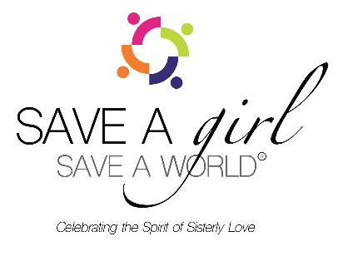

FOR IMMEDIATE RELEASE:

Press Contact: (Media Inquiries Only)
Cheryl Brownlee, Communications Director
cbcommunications@ymail.com |510-813-2122

SAVE A GIRL, SAVE A WORLD founder declares that women's right to choose” is disrespected by
U.S. Supreme Court decision.

Los Angeles (June 2022) In a 5-4 Supreme Court decision, Roe v. Wade, the landmark ruling that protected the constitutional right to abortion was overturned on June 24.

The decision is related to a highly restrictive new Mississippi abortion law. Tens of millions of people around the country will be affected by the new federal law.

Glenda A. Gill, founder of SAVE A GIRL, SAVE A WORLD (SAGSAW) made the following statement regarding the Supreme Court decision:
“As a founder of a multi-generational, young women and girls organization SAVE A Girl, SAVE A WORLD, I’m appalled and heartbroken that we live in a country that doesn’t respect women's reproductive ‘rights to choose’ for themselves and their future. This is a sad day in women’s herstory. Women this is not a day to be silent as we are under attack in health and voting rights.”

Roe, since 1973 had permitted abortions during the first two trimesters of pregnancy in the United States. With the ruling, individual states now have the authority to set their own abortion laws without legal restrictions concerning Roe.

According to the Department of Public Health’s “Policy Report: The effects of Abortion on the Black Community,” of every state that reports abortion by ethnicity; Black women disproportionately have the highest abortion ratio in the country, with 474 abortions per 1,000 live births.

Four major factors led to abortions, according to Black Demographics: Unintended Pregnancies, Relationships instability, Poverty, and lack of contraception use.

“Know that any limit on abortion access disproportionately harms Black women, girls, transgender, and gender non-conforming,” Gill stated. “The fall of Roe is painful, but now is a time to stay vigilant and engaged. We have tools at our disposal to resist, be change agents and advocates for our freedom.”

SAVE A GIRL, SAVE A WORLD focuses on making an impact on young women’s lives around the globe. Speak Project “Ambassadors” at Historically Black Colleges and Universities (HBCUs) campuses are assigned to open dialogue regarding health disparities that challenge Black women’s futures.

###

